Doncaster Dementia Insight Report
September 2022

About Healthwatch Doncaster
We are the independent champion for people who use health and social care services. We’re here to make sure that those running services in Doncaster, put people at the heart of care.
Our sole purpose is to understand the needs, experiences and concerns of people who use health and social care services in Doncaster and to speak out on their behalf.
We focus on ensuring that people’s worries and concerns about current services are addressed.
We work to get services right for the future.
Contents
About Healthwatch Doncaster 2
Summary 3
Introduction 5
Method 6
Demographics 8
Survey Demographics 9
Demographics - One-to-one interviews 11
Findings 12
Dementia Support Service and Choices 4 Doncaster 12
Survey 16
Happiness with services 16
What would you say went well with your/the person you care for getting a diagnosis, being referred and using services? 18
Positive responses 18
Mixed Positive and Negative responses 20
Negative responses 21
What didn't go quite so well? 22
Was there anything that wasn't available that you feel would have helped you/the person you care for? 26
Were there any challenges that you faced that made living with/caring for someone living with dementia more challenging, for example, other long term illnesses, loneliness, transport, employment, the effects of covid-19. 30
Group sessions and Interviews 35
Conclusions 41
Recommendations and/or next steps 43
Acknowledgments 43
Appendix 44

Summary

Healthwatch Doncaster were commissioned by Doncaster Council and Doncaster Clinical Commissioning Group (CCG) to understand the experiences of users of Doncaster dementia pathway services and their carers.
This report on our findings will inform the future strategic direction of services in the pathway and includes insights into dementia services, wider NHS and social care services and wider determinant of health factors.
To ensure accessibility engagement was undertaken using diverse methodologies and captured the experiences of those with dementia and their carers:
96 people responded to an online survey.
9 people filled in a hard copy of the survey.
137 people were engaged via dementia support groups
11 people had 1 to 1 interviews
In total, 253 people were engaged with for this report

Themes
A number of themes became evident from the engagement:
Lack of support
- This was a key concern for respondents, being raised the most in people’s responses. A significant proportion of people felt completely unsupported or their support was not adequate.
- Where support was in place, people were much more likely to be positive about that support.
- People described a lack of follow-up being a big part of the sense of being unsupported.
- People also wanted help with the financial implications of having dementia including care costs, and this seemed to be lacking.
- Some people were challenged where the person they cared for or the family of the person refused support.

Lack of information
- This is closely connected with peoples responses about lack of support, as information and signposting were seen to be the key to accessing services.
- Information was also felt to be lacking about how dementia progresses as a condition and what to expect, and which services are available at each stage.
- People talked about having to find things themselves, and even those in contact with services felt they did not have sufficient information.
- A number of people talked about how useful it would be to a single point of contact so they could speak to the right person. There were small number of comments about having too much information, reinforcing the need for someone to contact.

Navigating the system
- People talked about the complexity of the system, and how things don’t work well together. Hardly anyone mentioned being aware of a pathway or what to expect at each stage.

Assessment/referral
- Respondents had poor experiences of assessment/referral processes following diagnosis, either via the GP or consultant.
- A number of respondents mentioned not being referred to services following assessments by professionals

Diagnosis and treatment
- There were lots of positive feedback about actual diagnosis, with staff involved being described as caring and professional.
- Where people had negative experiences was in getting to the point of diagnosis, describing long waits and not being taken seriously by professionals when raising concerns.
- People also felt community mental health and therapy services needed to be improved.

Ethnicity
- Everyone who responded to the engagement described themselves as White British.
- This has implications for future strategy and commissioning as it is unclear whether this was because people from diverse communities are not accessing services, or that they are not linked into the communication networks for people with dementia and their carers.

Next Steps
The Dementia Insight Report has highlighted a number of key themes, these will be used to inform;
- Development of Doncaster’s Dementia Strategy and action plans
- Future procurement
- Pre and post diagnostic service
- Community Therapy and Support

Introduction
Healthwatch Doncaster were commissioned by Doncaster Council and Doncaster Clinical Commissioning Group (CCG) to understand the experiences of users of Doncaster dementia pathway services and their carers.
This report on our findings will inform the future strategic direction of services in the pathway and includes insights into dementia services, wider NHS and social care services and wider determinant of health factors.
The objectives of the commission were to;
- Gain a deeper understanding of those on the Dementia pathway in Doncaster and those supporting people on the pathway across demographic cohorts, compared to national data.
- Better understand the experiences of those affected living in communities that are known to be economically deprived.
- Gain a clearer understanding of the impact of health inequalities.
- Gain a deeper understanding of the impact of the Covid 19 pandemic.
- Establish through the findings some key actions that partners can take which would improve the wellbeing and support of those affected.
This report summarises the key issues from people who:
- Use services from each stage of the Dementia Pathway
  - Preventing Well
  - Diagnosing Well
  - Supporting Well
  - Living Well
  - Dying Well
- Are carers of people with dementia
- Have protected characteristics of the Equality Act
- Live alone or are socially isolated
- Have co-morbidities

This report includes peoples views on the wider determinants of heath such as:
- Impact of Covid-19
- Income and cost of living
- Housing
- Transport
- Loneliness
- Employment

Method
To ensure accessibility engagement was undertaken using diverse methodologies:
Online survey with hard copy survey posted to people on request
Following an initial meeting with the commissioners of the project an online survey was developed and a comms strategy devised to promote this. In addition to the commissioners’ comms offering Healthwatch Doncaster employed the following means of promoting the survey:
- Posts on Healthwatch Doncaster’s (HWD) social media
- A presence on the Healthwatch Doncaster website
- A press release – the content of which was picked up in the local Free Press and by Radio Sheffield (who also recorded a short interview to feature on news bulletins) and possibly others.
- A member of RDASH team disseminated to the RDASH networks
- Making Space promoting it via their widely distributed newsletter
- A contact distributed to Doncaster Council networks
- Royal Voluntary Service promoted directly to their groups via their newsletter
- Information was included in e-bulletins to the Dementia Collaborative
- Inspire promoting to their clients
- Our staff and volunteer cohort shared through their networks
- The survey was promoted to relatives of residents who reside in Runwood Homes across the borough
The survey ran from 4th July 2022 to 15th August 2022. 96 people responded.
The survey was designed to encourage predominantly open text, qualitive responses.
Demographic data was collected as well as information about services used, postcode and information on other health conditions.
The survey was distributed to known service users by Doncaster Council and the CCG, as well as voluntary sector organisations.
The full survey is in Appendix 1. Responses to demographic questions are summarised in the Demographics section of this report, responses are analysed in the Findings section of this report.
Face to face at dementia support groups
A range of support groups for people with dementia and their carers were visited, along with relevant statutory and third sector groups. These are listed below with the numbers of people engaged at each group.
Date | Group | No. Engaged
6.7.22 | Dementia Sub Group -Professionals. providers and people with lived experience | 14
19.7.22 | Principle Social Workers Meeting - Professionals | 8
27.7.22 | Conisbrough Music Café (Alzheimers Society) – People living with  Dementia and some carers | 16
28.7.22 | Dementia Collaborative – Professionals. Providers and people with  lived experience | 20
3.8.22 | Cantley Dementia Café (Alzheimers Society) – People living with  Dementia and some carers | 30
4.8.22 | Bentley Royal Voluntary Service (RVS) Dementia Group – People  Living with Dementia and some carers | 25
5.8.22 | Rossington RVS Dementia Group – People living with Dementia and some carers | 12
18.8.22 | Age UK Dementia Group – People living with Dementia | 12
Table 1 Support Groups visited

Face to face, online video and telephone interviews
11 interviews were undertaken, the makeup of interviewees is the Demographics section of this report, responses are analysed in the Findings section of this report.

In total, 253 people were engaged with for this report

Utilising existing insight from council, CCG, service providers and VCSE organisations
We reached out to stakeholders involved in commissioning and delivering dementia services to understand what insight already existed.
A number of stakeholders were in the midst of their own engagement with specific groups and so limited insight was available.
We received information from the council on the number of people receiving services and copies of the Locality Plans.
We also received summaries of the feedback gathered from service users of the Dementia Support Service and Choices 4 Doncaster. This summary can be found in the Findings section of this report.

Demographics
Information was provided by Doncaster Council on residents that use dementia services.
There are 733 service users, but it should be noted that the total of each row will add up to more than 733, as some service users have multiple open services (e.g. respite plus home care).

Service | Count
Day Care - Adults | 13
Direct Payments - Adults | 68
Extra Care - Adults | 13
Home Care - Adults | 165
Nursing Long Stay - Adults | 82
Nursing Respite - Adults | 1
Nursing Short Stay - Adults | 2
Reablement Home Services - Adults | 13
Reablement PSU - Adults | 3
Residential Long Stay - Adults | 369
Residential Respite - Adults | 94
Residential Short Stay - Adults | 36
Grand Total (Unique Individuals) | 733

The 253 people engaged with for this report would represent 35% of known service users

Survey Demographics
Person with dementia or carer
For most responses, the carer of the person with dementia responded:

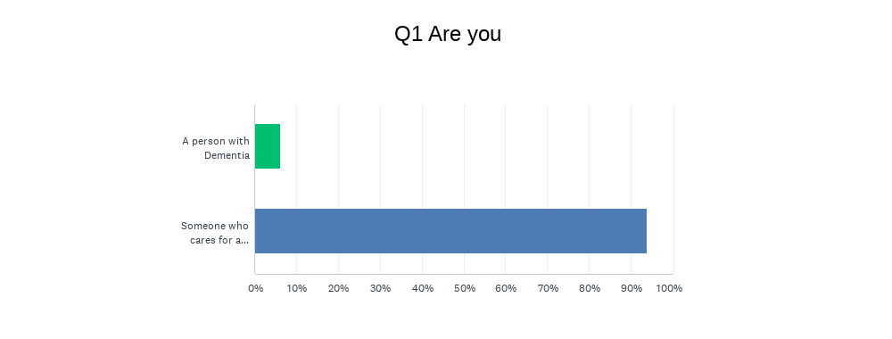
Figure 1 Summary of Q1 Are you a person with dementia or a carer?
All 9 of those who responded in hard copy were carers for people with dementia

Gender
Over 70% of respondents were women both online and via the hard copy of the survey
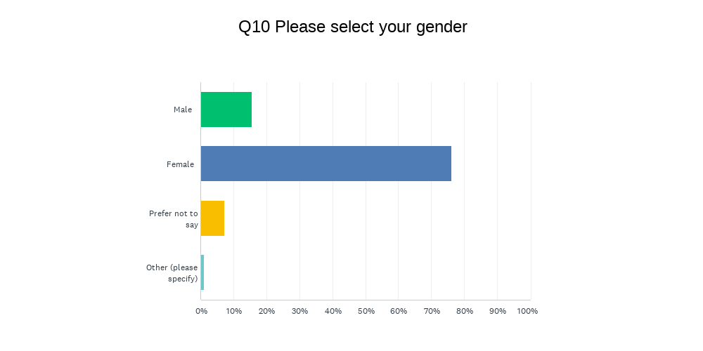
Figure 2 Summary of Q10 Gender

Age
There was a wide spread of ages that responded to the survey.
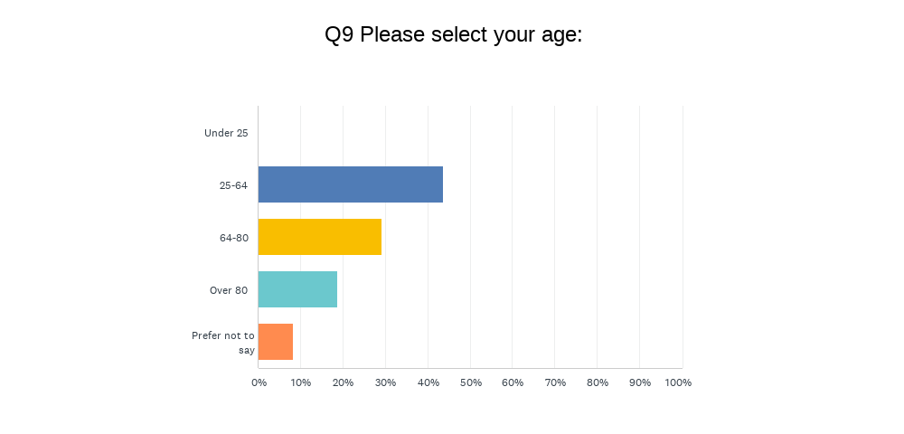
Figure 3 Summary of Q9 Age
For hard copy responses. Ages were:
Age range | Number of people
25-64 | 2
64-80 | 3
Over 80 | 3

Ethnicity
Everyone who responded to the survey, online and in hard copy, described themselves as White British.
This has implications for future strategy and commissioning as it is unclear whether this was because people from diverse communities are not accessing services, or are not linked into the communication networks for people with dementia and their carers.

Location
To ensure ease of data collection, we asked people for the first part of their postcode.
People engaged came from the breadth of postcodes across Doncaster. There was a reasonable response from postcodes that include areas of high health inequalities (highlighted in red in table 2 below).
Postcode | Responses | Postcode | Responses
DN1 | 3 | DN7 | 6
DN2 | 6 | DN8 | 3
DN3 | 11 | DN9 | 5
DN4 | 14 | DN10 | 5
DN5 | 17 | DN11 | 8
DN6 | 6 | DN12 | 7
Table 2 Numbers of respondents per postcode

Other long-term conditions
Almost half of respondents had co-existing long term conditions in addition to their dementia.
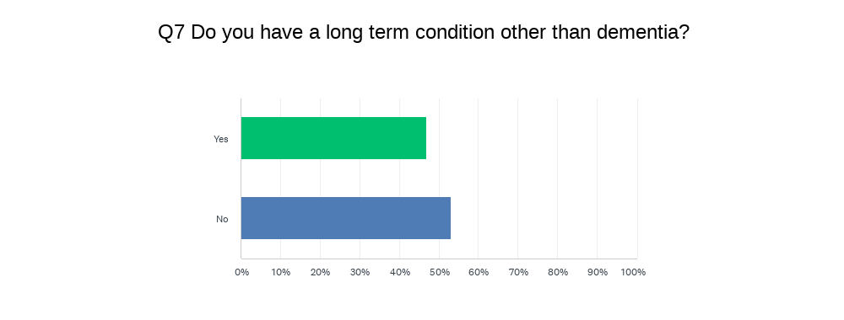
Figure 6 Summary of Q7 long term conditions
6 respondents via the hard copy of the survey also had a long term condition.

Demographics - One-to-one interviews
Carer | Person  Living with Dementia | Professional | Male | Female | Age  25-54 | Age  64-80 | White  British
7 | 2 | 2 | 2 | 9 | 10 | 1 | 11

Findings
This section sets out the responses to the open text questions in the survey along with the feedback from groups and the interviews.
It also includes the summaries of the feedback gathered from service users of the Dementia Support Service and Choices 4 Doncaster.
Key issues are summarised in the Conclusions section of this report.

Dementia Support Service and Choices 4 Doncaster
The commissioners of the Dementia Support Service and Choices 4 Doncaster require regular surveying of service users. Below are the summary responses for 201-22 and comments collected by the services and commissioner.
Dementia Support Services 2021-22
Question | Happy | Neutral | Unhappy
Has the support from the Alzheimer's Society and (volunteers' name) helped you to make choices about how you live and how you prefer to engage with your community? | 12
Do you feel more confident about doing things in your local community and asking for help when you need it? | 11 | 1
Do you feel that (staff member name) from the Alzheimer's Society was well trained, provided you with the right information and spoke to you in a way that helped you to understand? | 12
Have you been provided with the information you need to understand what you need to do now and to plan for the future? | 12
Have you been provided with information about opportunities to participate in Dementia research? | 5 | 6 | 1

‘We now have mum in day care 2 days a week and visit the local dementia café’
'The DSW (Dementia Support Worker) has helped so much answering questions with so much positivity'’
‘We do now have a good support network’
'Absolutely, it is hard to ask for help though'
‘The DSW has been absolutely brilliant, pointing us in the right direction to access the support we badly needed'
'The DSW made things with mum seem normal and that I was not alone'"
"The DSW is helping us to plan and replan as my mother sadly deteriorates’
"Yes I have already had mum helping out at our local surgery allowing trainee doctors to observe her reactions as the Doctor spoke to her'
'Some excellent work will participate where possible'"
Choices 4 Doncaster 2021-22
Question | Yes definitely | Yes generally | Not Really
Did you receive the service you wanted or expected? | 22 | 2 | 1

Question | All needs met | Most needs met | Some needs met
Has the service met your needs? | 14 | 10 | 1

Question | Very satisfied | Mostly satisfied
In general how happy are you with the service you received? | 24 | 1

Choices 4 Doncaster | Unhappy | Neutral | Happy
How has the support from Choices 4 Doncaster and the befriender helped you make choices about how you live and how you prefer to engage with your community? |  | 6 | 21
Have you been provided with the information needed to understand what you need now and to plan for the future? |  | 5 | 20
Are you more confident after working with choices 4 Doncaster that you know what is available, what is important to you and where you can get the right help? |  | 2 | 23

‘Alison’s visits really cheered my Mum up. She really enjoyed her company and conversation. I have been very happy with the service and more than happy to recommend to others’
‘Unfortunately it did not work as planned because Mum would not allow the befriender to do what was required. However the befriender came every week and kept Mum company which allowed us to get things done. The befriender left us with lots of knowledge and numbers of people that we may need in the future’
‘Happy with the befriending service and have arranged continuation with a private befriender. Has really enjoyed chatting with another lady. Family considering other respite services.’
‘Alison was superb and very tenacious in befriending Dad. She was warm and friendly and constantly looking for ways to connect with him. Despite Dads initial reluctance to leave mum Alison won his confidence and was able to take him for several walks in his wheelchair which Dad enjoyed. His comment was "she is a lovely person" which we all agreed with. Thank you Alison for your help when we most needed it.’
‘Very caring and understanding service’
‘When my daughter told me she had arranged for a befriender taster service I thought that I didn’t need it and wouldn’t enjoy it. But I have been really surprised how much I have enjoyed it and have looked forward to Alison’s visits. We have had great conversations covering a wide variety of subjects and interests . I am going to continue having a befriender visit me and I recommend this to others. What a great idea.’
‘This service is better than any medication. Having a befriender to discuss all aspects of my life as helped my confidence. I have been able to discuss my diagnosis of dementia openly and Alison has been very understanding and supportive. Time with Alison has set me up for the day and I feel very positive and happy after visits. Alison has encouraged me to consider going out again to the local garden centre and in summer to the local cricket club. I thought about it and I have taken the plunge with support from C4D and my daughter to continue with a private befriender. Thank you I have independence and a future to look forward to now.’
Was given information about social groups and been referred to RVS who have contacted me. The befriender was a lovely lady who explained a lot to us she is an asset to Doncaster. Very helpful, passionate befriender with great patience.
This information indicates that a significant number of users are happy or satisfied with the services provided.

Survey
The survey questions analysed in this section are:
- Happiness with services
- What would you say went well with your/the person you care for getting a diagnosis, being referred and using services?
- What didn't go quite so well?
- Was there anything that wasn't available that you feel would have helped you/the person you care for?
- Were there any challenges that you faced that made living with/caring for someone living with dementia more challenging, for example, other long term illnesses, loneliness, transport, employment, the effects of covid-19.
Analysis
It should be noted that as a consequence of asking open text questions, the detail provided varied enormously. Many people responded with a single word or sentence, often not identifying a specific service. Where respondents provided more detail, these are quoted or summarised under each issue raised by the responses.

Happiness with services
To set the scene, respondents were asked which services they had received and how happy they were with them:
- Extremely unhappy with the service
- Very unhappy with the service
- Fairly happy with the service
- Very happy with the service
- Extremely happy with the service
The results are summarised below:
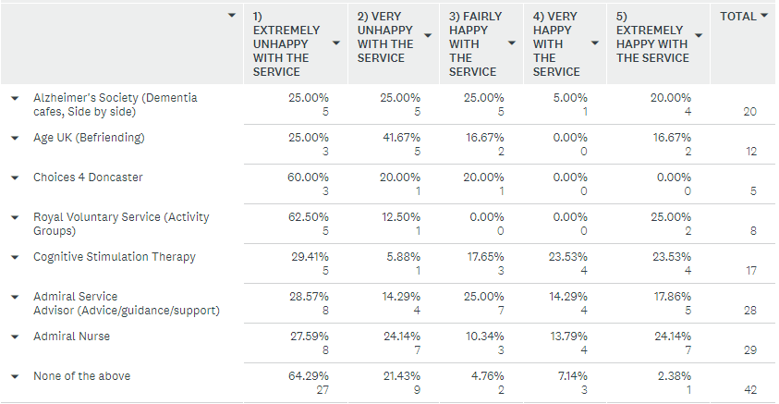
Figure 7 Summary of services referred to and level of satisfaction

There is evidence in the previous section that users of the Dementia Support Service and Choices 4 Doncaster are happy or satisfied with the service. This is not reflected in the feedback on the services gathered as part of this engagement, but it is a much smaller sample of responses regarding those services.
In summary all services respondents expressed a wide range of sentiment on the services they received, with no service having predominantly positive feedback.
Services Accessed by hard copy survey respondents:
Services | Number
Alzheimers Society | 2
Age UK | 4
Choices 4 Doncaster | 0
Royal Voluntary Service | 2
Cognitive Stimulation Therapy | 4
Admiral Service Advisor | 5
Admiral Nurse | 4
None | 4
Other | 2
Table 3 Services accessed by hard copy survey respondents

What would you say went well with your/the person you care for getting a diagnosis, being referred and using services?
Although the question asked for what went well, of the 96 responses 36 (38%) were actually negative, 41 (43%) were positive and 14 (15%) responses were both positive and negative.

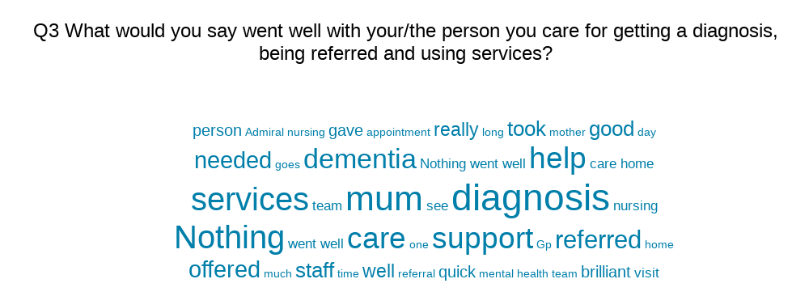
Figure 8 Word Cloud for responses to Q3

Positive responses
43 respondents were wholly positive and mentioned areas that went well such as:
- Diagnosis (10 comments)
- Admiral Nurses (8 comments)
- Mental Health Team (5 comments)
- Referrals (2 comments)
- Treatment (2 comments)
- Alzheimer’s UK (2 comments)
- Equipment and adaptations (2 comments)
- Day centres (2 comments)
- Access to information (2 comments)
- Access to support (3 comments)
- Adult Social Care (2 comments)
- Physical therapies (1 comment)
- Royal Voluntary Services (1 comment)
- Creative Support (1 comment)
- Music café (1 comment)
- Rotherham Hospital X-ray dept (1 comment)
- Support from council for person who is deaf (1 comment)
- Cognitive Stimulation Therapy (1comment)
(Some respondents mentioned more than one service)
‘The support we received from the Jade Centre mental health team, they reviewed mums memory regularly and any concerns I could access support and advice. We were referred to other professionals i.e. occupational therapy for road safety awareness as mum likes to go out to the shops by herself. Physiotherapist to review mums mobility and prescribed mum a 4 wheeled walker to aid her mobility when out walking. Also we were given lots of information to access day centres, befriending. Telecare for wrist pendants to keep mum safe. The Royal Voluntary Services are amazing, run by Jan B, she used to ring my mum or me to have a chat, it really helped, sent out activity packs etc.’
‘The dementia nurse help me through understanding how my mother was changing and saw things, not any help from anywhere else.’
‘Only been offered the Admiral Service.’
‘Access to support, meeting people in a similar position, having a contact to ask for advice or information.’
‘All went well, mum was a under consultant neurologist with cognitive impairment and then gave a dementia diagnosis. I am a social prescribing advisor and undertook a referral to the Admiral Nursing service who now support mum and dad and undertook the other referrals.’
‘Everyone was friendly and very understanding’
‘Doncaster Adult Services was a very good central point of contract and got the ball rolling for care for both my parents. At that point, I had no idea what to do. The initial support provided by the council's Steps team was really great. Over the next 4 years, we went through several care agencies for my mother and father, none were as good as Steps. The mental health dementia team at Tickhill Road were brilliant in getting my parents on the right medication and supporting my mum when she was admitted to hospital. The vouchers for respite care and the allowance for relaxation/leisure activities for carers was invaluable. Making Space day centres were brilliant. My dad went to Bently and my Mum went to Sandalwood. Both were very very good. They both enjoyed going and it gave myself and my partner a break.’
‘Just nice to know the support is there when needed.’
‘It all came as a big shock but the Admiral Nurse that was allocated to us was a wealth of knowledge and really helpful.’
‘Diagnosis was quick’
“It is now 7 years since first diagnosis – with a referral to Forest Gate – a very empathetic explanation by the doctor there at the time re. condition. Medication to help slow the development of Alzheimers immediately recommended and always monitored. Regular home visits to do so. Eventual EST, invaluable impact – helpful to myself as a 24/7 carer as well as being very beneficial to my friend of course. Carole Tramsen I/C and a wonderful asset at the time. Little input needed/pertinent to my friend Martin from Admiral Service.”
“Getting the support I needed, not on my own. Previously lived in Newark and once my husband was on the maximum dose for Dementia he was discharged from care!” Respondent indicated that care is much better in Doncaster.

Mixed Positive and Negative responses
15 responses were a mixture of positive and negative:
‘It was a long battle to get referred for initial diagnosis but once referred in 2017 the tests and assessment were comprehensive and timely.’
‘Had a visit or two from mental health teams but no follow up’
‘After 5 years I got offered day care and a support worker’
‘The carers course was good. As for rest from start to end it’s been very difficult’
‘The cognitive stimulation therapy is the only positive. Otherwise our experience was negative’
‘Diagnosis was fairly quick. Referral was quick but there was a 6 month wait with no advice’
‘Took quite a while for diagnosis, was later told about services available but my mum and I know at the time my dad wouldn't allow anyone else to intervene in his care’
‘GP diagnosis was quick but nothing afterwards’
‘When my service users are seen it is brilliant but the time it takes to be seen is too long.’
‘Getting 45mins for 12 weeks one to one mental stimulation only possible as I the carer could transport’
‘The side by side outings but had nothing since covid and that goes for Admiral as well’
‘Yes, but when dad went in care all serves stopped’
‘Eventually (the things that went wrong in other answers) Mum ended up in a superb care home – Ivy Court - quite by luck really. It's marvellous and she seems to be getting on well there. There were lots of assessments along the way. The doctor who eventually made the official dementia diagnosis was very caring and explained at length during an hour's phone call (during the pandemic) Runwood Homes pandemic measures were very good and they were well prepared - never ran out of what they needed. Runwood Homes staff were all fine and most were excellent - caring, friendly and supportive’
‘Getting a diagnosis went well. Not much after that.’
‘My husband was referred from the hospital, the first appointment was quick but been very slow since he has not had a appointment in a year’

Negative responses
There were 36 respondents to the question that answered negatively i.e. nothing went well. Issues included:
- Nothing went well (26 comments)
- Not referred to support (7 comments)
- Complexity of the system (2 comments)
- No useful information (1 comment)
- No offer of services (1 comment)
- Lack of contact (1 comment)
‘We were given some literature that didn’t seem to offer any support for my mums needs’
‘I didn’t feel anything went well, I felt we were just left, I had to seek help myself for my Mum’
‘Diagnosis was a long time happening. And we are still basically on our own apart from Admiral nurse every 6 weeks. She pointed us to RVS as well.’
‘There was nothing referred at all no help or anything from anyone a disgraceful outcome from expectations of help’
‘Getting the diagnosis was a relief but accessing services complex and disorganised made mum even more distressed’
‘I am not really getting any additional advice/help since the diagnosis. Rubbish, never happened’
‘Nothing. My mum passed away in a care home that treated her very poorly and I feel that she was let down by every person involved from the staff at Dri to the care home and all other agencies involved. Something needs to change as our elderly loved ones are being let down appallingly.’
‘Nothing to be honest. I've felt like me and my brother have been left to deal with everything on our own.’

What didn't go quite so well?
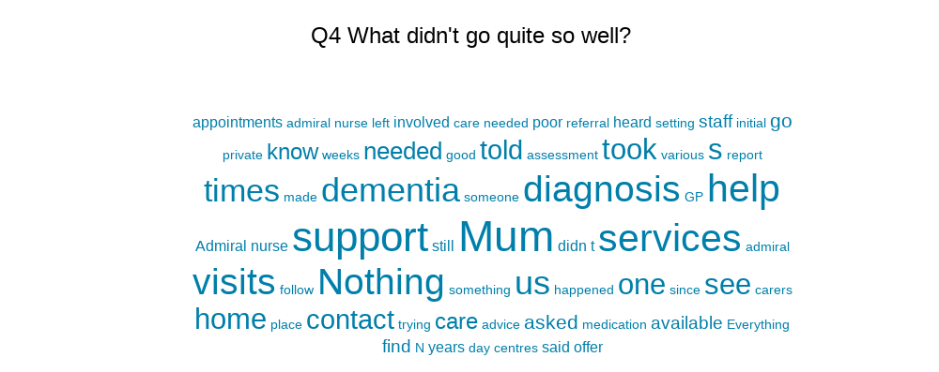
Figure 9 Word Cloud for responses to Q4
Lack of support
21 respondents had poor support including:
- Complete lack of support
- No follow up
- Feeling ‘left to it’
- No financial support
- Not meeting eligibility criteria
- Impact of Covid-19
- Information only
- Services not providing appropriate stimulation
- Services being impossible to navigate alone
- Family not understanding and accepting support
‘We still don't have any support’
‘Nothing went well at all there was no help or assistance from anyone I was disgusted I thought there would be some assistance but nothing whatsoever despite reporting my mum as vulnerable and in danger any one who got involved just didn’t help at all’
‘No support or follow up. It was only because I work in social care and a dementia setting that I was able to ensure my sister got the care she needed.’
‘Didn’t find anyone to help with paperwork for financial support. Asked various organisation if they could identify any activities or clubs all said they didn’t know’
‘The Alzheimer’s society worker was the only proactive worker to maintain contact even though mum did not wish to speak to him. When I was at my lowest point I could not reach the Admiral nurse. I left a message for her to contact me and this did not happen.’
“There was a total lack of care and consideration for my wife, who is also physically disabled. There has been no constant follow ups of the situation or my own wellbeing”
Positives
Although the question asked what didn’t go well, 16 respondents answered the question positively and felt there was nothing that could be improved.
‘I am unsure if my family could have been encouraged more often to take up support. I felt the professionals involved in their care did all they could to offer support and help.’
‘Nothing’
‘Excellent help from Sandall Park Day Care Centre.’
Lack of information
15 respondents flagged a lack of information being available as the area that could be improved.
‘No one came forward to help, or give advice’
‘There was no person/organisation which provided a central point of contact for support and advice. We stumbled our way through the process of diagnosis and gaining support - a pointer here from the GP receptionist, a pointer there from a carer, another from a friend. It was more a case of stumbling on support than being made aware of it.’
“Finding out about services available took a while and was fragmented on a need to know basis. If a comprehensive list was given with diagnosis it would be very helpful and reassuring at a time when it was most needed”
“No information given on either the condition or help available”
“Not knowing or being able to discover what to expect or how the disease would progress”

System
12 people talked about the complexity of the system, and how things don’t work well together. Comments were also made that services that only provide short term support are unsatisfactory.
‘Very trying to get the care that was needed, trying to work with professionals slow. Too many different departments’
‘We still felt a bit lost in the system’
‘To be honest once most of them have ticked their boxes that’s probably the last you hear or see them’
Assessment/referral
11 respondents had poor experiences of assessment/referral processes following diagnosis, either via the GP or consultant.
‘Nothing. Nothing has happened since diagnosis’
‘They called in when I asked them to see my mum but just did a memory test. Nothing was available for us as we would be self funding’
‘Had no referrals’
Diagnosis
9 people felt the experience of getting a diagnosis needed to be improved including:
- The length of time getting a diagnosis
- Lack of clarity about how the diagnosis is undertaken
- Poor communication from the Mental Health Team
‘Diagnosis taking 2+ years No explanations of what was happening Once diagnosed, left for 14 weeks and only had contact because I chased them’
‘It was getting someone to take me seriously because I could tell things weren’t right’
‘The Mental Health team who were involved in the initial diagnosis were not so easy to contact we were often passed from pillar to post.’
“Nothing went well we ended up paying privately and going to Claremont to get a diagnosis. My daughter then contacted the Admiral Service in Doncaster for help”
Admiral Nurses
7 respondents mention the Admiral Nurse service, with concerns that only being visited annually was not sufficient, lack of communication and follow up from discussions and visits.
‘Diagnosis made. One visit from a non too warm nurse and then left to it. No contact with or offered by anyone medical after this in relation to my mother’s Alzheimer’s. With the exception of a short weekly course with the cognitive therapy group. Sorted out own support and got excellent help from Sandall Park Day Care Centre.’
‘Terrible service, no follow up, didn’t re-visit with what they promised, never returned my calls.’
Communication
5 people raised communication issues such as:
- Not being able to answer calls because they are during work hours
- Deaf needs such as BSL
- Staff only recognising issues when seen face to face
- Lack of regular contact
‘I am not always available by telephone due to my employment commitments and missed calls are not followed up’
‘Staff didn't understand that they needed to book a BSL interpreter. Assessment wasn't undertaken understanding the cultural needs of the deaf community.’
GP
5 respondents had issues with their GP, mainly around diagnosis:
‘From asking the GP to do a mini mental test the GP told us to go online and do one ourselves. When asked again a few months later they did one but took ages to actually get anyone to do a proper assessment and get a diagnosis’

Covid
2 respondents commented in this question on the challenges during Covid 19 such as isolation and lack of services.

Staff behaviour
2 people raised staff behaviour:
‘I would have preferred someone I could trust to talk to.’
‘Staff that don't listen, no empathy, poor record keeping.’

Was there anything that wasn't available that you feel would have helped you/the person you care for?
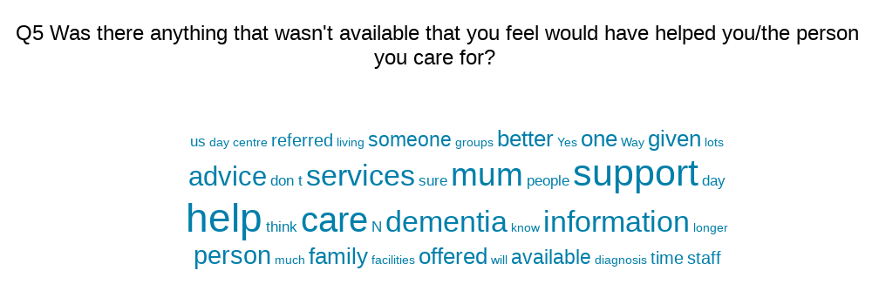
Figure 10 Word Cloud of responses to Q5
Access to information
32 respondents wanted better access to information including:
- Better signposting
- Not having to find out for themselves online
- Advice at an early stage
- A single point of contact
- Information on the progression of illness and behaviours

‘All advice and information regarding my mums care and needs was delivered to a minimum. We were given no links to services for support or advice.’
‘A close friend of my sister had experienced something similar with her mum the previous year and was able to offer us better guidance than the Mental Health Team or the websites online.’
‘More information about the progression of the illness and behaviours and the best way to support the sufferer.’
‘Would have liked some signposting to other facilities /services who could offer support. Also some advice on things like council tax exemption, national power priority customer scheme, local authority emergency alarm scheme etc. Had to seek out all these things ourselves.’
“Information on the condition and help available”
“Telephone numbers of people who could help me eg Admiral Nurses or NHS teams”

Access to support
30 respondents wanted better support including:
- Better support from Social Services
- Carer support
- Any support being offered as none was
- Help with entitlements
- Honest conversations and support for families and partners
- Single point of contact
‘Any help would’ve been good.’
‘A central point for men to attend on a regular basis providing helpers to give e.g. working with wood gardening improving and maintaining cognitive functions’
‘More competitive priced private domiciliary care options when the client is self funding’
‘A Code of Practice would be a great help, so we could compare what should happen with what actually happens.’
‘It needs to Holistic to the individual. My mother can’t cope with everything and sort through forms and paperwork. Way too much paperwork information, not even relevant. The cost. If people cant afford the services of day care. Befriender, they are stuck at home with unable to see anyone.’
‘My son sorted out I think it's called echo to remind me to take my tablets and turn lights out’
‘Home based befriending. Check calls through the night for when mum is unsettled and calling me and emergency services for help.’
‘Someone to come and chat to mum would have been good. She is much better now in private dementia care home.’
“ I needed help looking after my wife, which I initially had to pay for , so could only afford 1 hour a day which was not enough. I later found out that I didn’t have to pay but care is poor and not sufficient for either of our needs.”

Positive or unsure
Although the question was what could be improved, 20 people felt nothing could have been improved.
‘Not that I can think of, may be we were a little slow on taking up what was on offer. I cannot praise the Admiral Service and the Royal Volunteers highly enough.’

Diagnosis and treatment
7 people wanted improvements in diagnosis and treatment such as:
- Improved Community Psychiatric Nurse service
- Improved Speech and Language service
- Being listened to when have concerns
- More thorough assessments
- Help before diagnosis

‘My mum was deteriorating quickly and I felt the CPN did not believe the information I was giving him as mum continued to present well until almost the end. No one from the local GP practice came to visit mum. I could not get her there due to her mobility issues. The practice nurse offered some support but again did not try to see her. Eventually mum was referred to 3 consultants and I felt this was a case of lets try all as we don’t want to see her to enable the correct referral to be made.’

System
4 respondents described issues with the system more widely.
‘It was appalling.’
‘The groups that we were referred to were too costly. We fell just above the financial threshold so were liable for costs’
‘Everyone you contacted were so separated from each other. Social workers, hospital, local GP. It was very hard work as if each sector wasn’t communicating with each other.’

Admiral Nurses
There were 3 references to Admiral Nurses
‘Admiral was ok at times but constantly busy and closed our case didn’t feel fully supported’
‘It would have been good to see the dementia nurse from the start not at the point I was not coping’
‘Not that I can think of, may be we were a little slow on taking up what was on offer. I cannot praise the Admiral Service and the Royal Volunteers highly enough.’

Alzheimer’s UK
There was a comment on how Alzheimer’s UK could improve:
‘To give anyone your full attention and work on a person centred approach would be a better staffing level for more quality time as having a activity coordinator they cannot work with several dementia patients at one time.’

Referral
There were 2 comments about referrals:
‘If my mother had been referred to someone I am sure it would have been of benefit to her and her family.’
‘Can't really say as not referred’

Support for people who are deaf
Comments were also made on improving support for people who are deaf:
‘Access to information and Dementia specialists in British Sign Language’
‘Signing staff, staff with understanding of BSL users’

Were there any challenges that you faced that made living with/caring for someone living with dementia more challenging, for example, other long term illnesses, loneliness, transport, employment, the effects of covid-19.
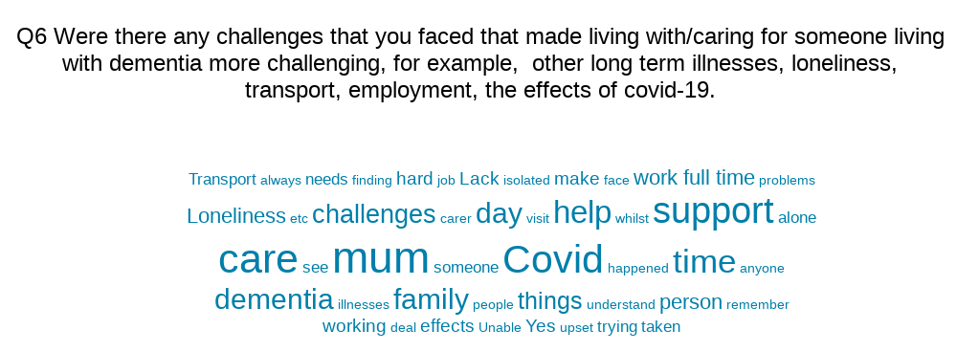
Figure 11 Word Cloud of responses for Q6
Covid-19
19 respondents raised Covid-19 restrictions, in particular the huge reduction in services, isolation and the challenges for people with dementia to understand what was happening.
‘Covid had a huge impact. Our Mum was taken into care - something she had begged us to make sure never happened - and we couldn't visit her to explain or comfort her. She now won't speak to us and is angry whenever we visit. I'm not sure our relationship will ever recover. Thankfully Mum still enjoys our children - her grandchildren - and loves their visits - as long as they don't mention us. Mum had depression before the dementia reared its head, but mental health services apparently couldn't be triggered while she had delirium and she became more and more down as the two years went on. The fight to get anyone to take her depression seriously was wearying’
‘Explaining lock down and trying to make someone stay home when they don’t understand was very tough. Loneliness plays a part in wanting to wander around too which adds to the problem’
‘Mum had another illness which was not diagnosed and she died with us not knowing what the issue was. As mum`s friends could not visit her she was alone and continued to phone me at least 50 -60 times each morning until my husband picked her up and brought her to our house each lunch time. I was working from home and the pressure was immense.’

Loneliness
16 people referenced loneliness as a significant issue.
‘Loneliness for mum. Not feeling believed by services. Worrying that ambulances are called out for no good reason by mum. Constant worry and guilt re mum and the effect my caring role has on my husband’s quality of life. Financial consequences as I would have liked a part time job after taking early retirement but not able to and not able to get Carers Allowance.’
‘Loneliness of dementia person, especially during Covid. Sorting out medication due to development of other condition needing different doses of medication. This would have been impossible For dementia person without support from family.’
‘Obviously there are lots of challenges that families caring for someone with dementia face. Our mum was feeling extremely lonely. She has been a strong independent woman living alone and bringing up 3 children as a single parent. Now she cannot remember when someone has visited through the day even though we have started with a care package with 4 carers a day calling in to prompt medication and eating etc.’

Other Caring responsibilities/ demands on carers
15 respondents talked about the challenges of caring whilst having other work/family commitments.
‘The fact that I had my own life, house and job and was/still am expected to do the day to day things, which is quite wearing, but on top of that every time there is a setback, which have become more and more frequent, all that falls on me as well. There is no backup ad no one to turn to for help. My parent still has capacity and “doesn’t need any help” as long as I’m available all day every day, which is not sustainable. Medical services, 111, GP not overly helpful, with any consultation starting off with what they CAN’T do.’
‘I worry about long-term issues permanently as I do not know what is available to assist me with caring’
‘Working full time Mum living alone Family life in general Not feeling qualified to deal with it and not given any practical advice, just left to try our best and not knowing whether we're doing the right thing day in day out’
‘It was hard initially to remember to keep all the doors locked and the keys out of sight. It was also distressing to see her get upset when she couldn't remember things.’
‘Everyday is a struggle’
‘Challenging behaviour’
‘This section should start with Are there, not were there. Isolation Other illnesses Own illnesses Stress Tiredness Guilt Worry Living Grief Lose of independence Etc, etc.’
“Yes my life is now hell! With a fight to do anything”
“My health suffered mentally and physically during Covid and when we caught it – had to keep in caring when ill myself not able to meet friends due to not being able to leave the person I care for. Also not able to see/look after young grandchildren as often as I would like due to caring responsibilities”

System
11 people cited the complexity of caring and having dementia and the wider system as the main challenge for them
‘Lack of input from professionals in spite of referrals from GP’
‘No help from anywhere’
‘Frustration on both sides’
‘Unable to contact one as and when things get worse. You just feel as we have been told by our surgery one is on your own.’
‘Mum used to cross York road to go to Morrisons, despite raising this there was nothing positive, I should just have put my mum in care earlier than I did’

Transport
9 respondents talked about transport challenges including:
- General lack of transport
- Motability limitations
- Challenges for family and carers to provide transport

‘Transport mum cannot get in to my car anymore .. I work full time in education so apart from carer she doesn’t see anyone.’
‘Transport to the day centres by St Leger is invaluable but unreliable . Despite paying for a full day at a centre you can not get a bus early to get you there. Also they bring home early. The drivers are great but needs more and better offer.’

Employment
6 people talked about the impact of their employment.
‘I was running the family business and caring for a mum with vascular dementia and a housebound husband with various medical conditions. He only help we got was once for each person following hospital stays. STEPS came in to help. Otherwise I paid privately for carers for mum 4 times per day’
‘Trying to hold a job down at same time’
‘Had to give up my job to care for mother with obvious financial implications.’
‘Having to work full time whilst caring for 2 parents with dementia. Covid-19 was a big problem as, at the time, the carer agency could not access PPE and carers were arriving with no masks. I had stopped working because of lockdown and I cancelled the carers and myself and my partner looked cared for my mum ourselves.’

Other illnesses
7 people talked about the impact of the person with dementia or their carer having other illnesses.
‘Every day is a challenge on a practical level my father deals with mums dementia 24/7 with only the respite provided by myself and my daughter. I have a long term chronic health condition and my daughter has a young baby and works two jobs besides’
‘Professionals were less likely to treat the physical health issues as they would for people without dementia. I had to fight for every intervention.’
‘Mum was very lonely, she had type 2 diabetes and couldn't move about very well. She was seen by falls team and had physiotherapy sessions up until March 2020 to help her gain more confidence. Mum had a catheter which she found upsetting’
‘My mum had many other illnesses. Apart from the extremely poor physical care she received she was also medically neglected resulting in her developing sepsis from a strangulated hernia that was left untreated. Her death was never needed to happen at that time if she had received the care she deserved and her last days were isolated whilst she was no doubt in horrendous pain. She went through this alone as we were unable to see her for more than the allotted 30 min daily visits due to covid. She was left in a room to die alone’

Services
There were 3 comments about specific services:
‘Before we had support from the Alzheimer's Society we felt totally alone and wasn't sure if we were doing things right or making the situation worse in caring for mum’
‘The supported living complex she lived in Harrogate Court was totally, dementia unfriendly. The staff at the time were lacking in even basic knowledge of dementia. There were lots of other challenges: finding care and support’
‘No support. The only support was from Inspire Doncaster Ltd they are amazing helpful, knowledgeable’

Finance
There were 2 comments about finance:
‘The fact that my mother was a hoarder made things far more difficult and the financial cost of dealing with clearing things all the time I feel should not have been down to my mum as it’s an illness’
‘Paying for day centre independently- we're pensioners!’

People who are deaf
There were 2 comments about the impact for people who are deaf:
‘Being Deaf with Dementia, is very confusing . its hard for professionals to explain what's happening and hard for the person living with dementia to understand.
Staff wearing masks meant that communication with was even more limited for the deaf person as they couldn't see facial expression or lipread. Few services/groups for deaf people so isolated in hearing environments with no communication’

Group sessions and Interviews
This section summarises the feedback gathered when we attended groups organised for people with dementia and/or their carers. During the visits we did a combination of 1 to 1 interviews and talking to the whole group. We also did some additional interviews over the telephone or zoom. We also had feedback from a group engagement session held in May 2022. Discussions are summarised below.
Due to the short timescale we concentrated our efforts on groups and individuals with a direct Dementia connection whilst at the same time trying to incorporate some of the services on the current pathway. We interacted face-to-face or virtually with over 137 people to gather their views, this is in addition to the individual interviews.
We reviewed our approach during the project, the survey was showing a fairly even spread of geographical responses across the borough but the ethnicity data however was less so, with responses being predominantly from people declaring their ethnicity to be White British.
We had anticipated this and had approached community contacts who would be able to act as a link to under represented groups with a Dementia focus. We only received one response which unfortunately came back too late to follow up.
Timetable of group visits
Date | Group | No. Engaged
6.7.22 | Dementia Sub Group | 14
19.7.22 | Principle Social Workers Meeting | 8
27.7.22 | Conisbrough Music Café (Alzheimers Society) | 16
28.7.22 | Dementia Collaborative | 20
3.8.22 | Cantley Dementia Café (Alzheimers Society) | 30
4.8.22 | RVS Dementia Group - Bentley | 25
5.8.22 | RVS Dementia Group - Rossington | 12
18.8.22 | Age UK Dementia Group – People living with Dementia | 12

Interview Date: 21st July 2022 | Charity Co-ordinator (in person) | Female / 64 80
MAIN THEMES-
Lack of information on diagnosis- people left to than own devices
Don’t know what is out there
Better communication required including between agencies and groups
Carers who have lost the person they were caring for tend to continue to access groups- there could be better provision for people in order to help them move on.
People have lack of capacity to access websites, this needs to be taken into consideration and everything shouldn’t just be online.

Interview date 25th July 2022 | Former carer – (in person) | female / 25-64

My parent was handed a load of leaflets when diagnosed, as carers we didn’t know what was available. Would have been more helpful to have a named person who we could contact with any questions and who could explain things. No one has time to read and digest leaflets.
Adaptation team at the council were good sorting pendant, watch and toilet, bed frames and meals on wheels.

Gaps -It would be good if there were a centre for carers and people living with dementia to access pamper sessions ands things like hairdressing.
MAIN Theme - LACK information about support available-at point of diagnosis

Interview date 27th July 2022 | Carer for relative - in person at music cafe | Male/ 25-64

Not signposted at diagnosis or since but attends Alzheimer’s music group and singing for the brain also enjoys flower arranging and watching live entertainment.
"There should be ‘creche' facilities available for carers – a place where the person living with dementia can stay safely whilst their carer attends appointments for example.’

Interview date 27th July 2022 | Professional (in person) | Female/25-64

"Groups offer a great opportunity for peer support -transport can be an issue.’

Interview date 1st August 2022 | Carer (telephone) | Female/25-64

Relative diagnosed with Vascular Dementia (no information given about the condition at point of diagnosis) Very little information about services available. Attended Alzheimer’s Music cafe and found about other groups from other attendees

Interview date: 15th August 2022 | Carer (telephone) | Female/25-64

Carer for parent with Alzheimers
Diagnosis took as long time, had to wait for appointments for memory assessment etc
“The Dementia Charter for Doncaster says that people living with Dementia need to stay active and engaged. However Council funded day centres have been withdrawn and people now have to pay to attend these services. The services provided by Making Space are good but need to be publicly funded. Day Centres provide much needed respite for carers and mental stimulation for people living with Dementia and help people to live longer at home rather than having to go into care. You have to look after the carers and the person they care for”
Admiral Services are really good but only offer support early after diagnosis then you are ‘signed off’
Things like community dental visits are available for people living with Dementia but no one told me that (the professionals I asked didn’t know) I had to find out for myself and there are long waiting lists
It was mainly not for profit organisation that helped us Donmentia, Citizens Advice, DIAL
Transport is an issue St Leger drivers are excellent the admin team are difficult to deal with and they often don’t come at the times when you need them to so you pay for a day at the centre but transport means you don’t get full benefit. There needs to be a better funded transport offering as the current lack of resources causes issues
It would be helpful if there were a list of support available
It would be good if GP practices had a Dementia Champion who could signpost newly diagnosed patients and their carers

Interview Date: 12th July 2022 | Former carer (telephone) | Male /25-64

Personal experience of caring for and losing 2 family members to Dementia
Main themes-
Empowerment through information
There needs be more information available about pre diagnosis routes to testing and where to go once diagnosed
"I have knowledge of the pathway and still found it difficult to navigate when we had to access it. People who don't possess that knowledge are going to find it much more challenging”
End of Life
"Hospice care is available for people with Dementia at end of life but you really need to press for it, we did and were able to get the care needed.
General
It is great that a pathway has been developed but there is still some way to go especially around information and communication

Interview Date:18th July 2022 | Provider (Z00M) | Cath McGee (Making Spaces)

3 services –
- Sandalwood Day Centre (since 1st April 2022 funding ceased, attenders now self fund)
Demand for day care is higher than available provision

- Wellbeing Services
Service for I8+ unpaid carers
Staff are currently undergoing training to undertake carers assessment.
Issues highlighted – delays in initial diagnosis difficulty in accessing. support

- Admiral Service
3 Admiral Nurses -caseload of 30 each (one nurse off long term sick)
4 Advisors- (one for each locality)

Main themes:
- delays in diagnosis
- lack of a named point of contact
- needs to be a single point of access for information (website)
- Barnsley have a universal health passport which negates the need for carers to Keep repeating information and also leads to a better experience

Interview Date 18 July 2022 | Person Living with Young Onset Dementia – (ZOOM) | Female/25-64

Diagnosed at 40 took a long time to get GP to take concerns seriously
Services currently accessed - - Young Onset Dementia service (under 65s)
PA daily/support worker once a week/CPN
"The support worker weekly helps me to keep independent when it is coming up Christmas my support worker helps me buy and wrap presents for my family, this is more than a shopping trip – it means a lot.
The Young Onset Dementia Service is fantastic it caters for people my age- Vera Lynn is not bad but not my cup of tea!' The service provides peer support, it was much missed during Covid its opened up now but transport hasn’t started up again which is an issue for people.
The themes discussed at a Dementia engagement Forum in May were shared with us by stakeholders:
Dementia Engagement — Dementia Forum — 11 May 2022
- Lack of follow up following the short intervention provided by Mental Health Nurses have felt no aftercare provided by GP service
- Happy with quality of carers attending the home to deliver borne care on the whole one comment was made that some appeared better trained for dementia than others however the majority of care here was completely self-funded and put in place by relatives so they felt this had been down to them and therefore they felt had not had any help in this area
- One person said they were given vouchers for 6 weeks of respite nursing home care and the care received here was very good but 6 weeks was not enough when looking after someone with dementia which can be years.
- An informal diagnosis of dementia did not allow them to access to any of the other services
- No follow up from GP services following a diagnosis of early onset vascular dementia had left person not knowing what state of progression the disease was in and no care plans in place (an annual assessment may give piece of mind and also map disease as to when other interventions may be required), however they felt that they did have support from the sheltered housing they were living in and did not feel isolated
- Lack of hospital care in that it did not take into account the needs of the patient with Dementia when accessing the services for other treatments required such as arthritis and the constant changing and cancellation of appointments were confusing
- Not being diagnosed with dementia until they were accessing palliative care even though the GP had been aware of issues that suggested dementia
- Good signposting by Alzheimer's Society
- Early onset dementia picked up by Sheffield Hospital Trust that had been missed by GP
- Alzheimers Society closed down support groups but the support groups were well received when they were running
- Really valued the Dementia Forum as a support group and what it was giving them Lack of communication - The Post Diagnostic Service was not clearly explained to people what the service actually provided
- No communication from RDaSH about what was happening. Someone came out to assess and they gathered information and then was informed of diagnosis by consultant — PWD and carer felt puzzled about the process and how someone who had not seen the PWD could provide the diagnosis — process not explained to them.
- The group felt the forum provided them with great peer support People in group felt more of the peer support groups were needed
- Some of the group had accessed the befriending service and thought it was very good as it was important for carer to have some respite and really valued the service from Age UK
- A couple had accessed the CST service and thought it was useful

Royal Voluntary Service (RVS) Dementia Group – 4 August 2022

Attendees: RVS staff and volunteers, Individuals living with Dementia, Carers

A discussion took place with the individuals living with Dementia:
The group were full of praise for the weekly session they attend with the RVS the reasons they cited were –
- That they provide a range of engaging activities
- They are a great means of peer support
- That they feel they are treated like individuals
- “The day centre I attend isn’t lively like this group, I feel at home and we do interesting stuff here
All participants expressed a wish for the sessions to be more frequent, preferably daily.
Views from Carers:
- The sessions provide much needed respite for carers. Respite is hard to access and there is little or no information about what is available and how to access it.
- “Admiral services offered intense support for the first few weeks and then nothing” other respondents said that they had found the Admiral Service helpful
- “We have to pay for home carers and it is too expensive, there is not enough financial help”
Views from Volunteers:
- Demand to attend groups outstrips capacity, we run as many groups as we can with the limited resources that we receive
- It is important that groups support independence, be person centred and see the person not the label
General issues that were raised as matters for concern and discussed by the whole group:
- Transport - is a massive issue for example taxi firms now a mainly reliant on apps for booking this can be problematic. Community transport is good but is a limited resource.
- Information – The majority of the group felt that there could be better access to information around support and services available for those living with Dementia and their carers. One participant said that they felt overwhelmed at the point of diagnosis when they were bombarded with information.

The overall impression of the group was that it is a well run group that fully embraces a person centred approach and is a great source of support for people living with Dementia and their carers. In addition to providing weekly respite for carers and meaningful activity for those they care for they work with other services (Admiral Service primarily) to ensure that everyone is getting the support they require.

RVS Dementia Group – 5 August 2022
Main themes from the group were:
• Telephone consultation from GP’s not suitable for people living with Dementia
• Admiral Service are amazing. Their service seems to be limited to the initial period after diagnosis but they are good if you contact them.
• More groups needed

Session on 18th July 2022

- They would welcome more activities like groups, trips out and a walking group for the more mobile
- They would like more transport to be able to take them out and about

No feedback on services accessed one lady I spoke to said her daughter had found out about the Age UK group for her, she wasn’t aware that they had been referred to anything. The group leader said that they do get referrals from a number of sources including professionals.

Age UK Dementia Group – People living with Dementia 18th August 2022

- Attendees would welcome more activities like groups, trips out and a walking group for the more mobile
- They would like more transport to be able to take them out and about

No feedback on services accessed, one lady we spoke to said her daughter had found out about the Age UK group for her, she wasn’t aware that they had been referred to anything. The group leader said that they do get referrals from a number of sources including professionals.

Conclusions
A number of themes became evident from the engagement:
Lack of support
This was a key concern for respondents. It featured highest in the responses to ‘What didn’t go well?’, is implied in the large number of negative responses to ‘What would you say went well?’ and was the second highest issue raised under ‘Was there anything that wasn't available?’
It was also reflected in the responses to the question ‘Were there any challenges that you faced that made living with/caring for someone living with dementia more challenging?’
Where support was in place, people were much more likely to be positive about that support, as can be seen in the comments about specific services such as Alzheimer’s UK, Admiral Nurses care services and the support groups attended.
However a significant proportion of people felt completely unsupported or their support was not adequate.
People described a lack of follow-up being a big part of the sense of being unsupported.
People also wanted help with the financial implications of having dementia including care costs, and this seemed to be lacking.
Some people were challenged where the person they cared for or the family of the person refused support.

Lack of information
This is closely connected with peoples responses about lack of support, as information and signposting were seen to be the key to accessing services.
Information was also felt to be lacking about how dementia progresses and what to expect, and which services are available at each stage.
This was the second most raised issue for to ‘What didn’t go well?’ and the highest for the question ‘Was there anything that wasn't available?’
People talked about having to find things themselves, and even those in contact with some services such as Admiral Nurses felt they did not have sufficient information.
A number of people talked about how useful it would be to a single point of contact so they could speak to the right person. There were small number of comments about having too much information, reinforcing the need for information and someone to contact.

Navigating the system
people talked about the complexity of the system, and how things don’t work well together. Respondents did not mention understanding a pathway or what to expect at each stage.

Assessment/referral
Respondents had poor experiences of assessment/referral processes following diagnosis, either via the GP or consultant.
A number of respondents mentioned not being referred to services following assessments by professionals

Diagnosis and treatment
There were lots of positive feedback about actual diagnosis, with staff involved being described as caring and professional.
Where people had negative experiences were in getting to the point of diagnosis, describing long waits and not being taken seriously by professionals when raising concerns.
People also felt community mental health and therapy services needed to be improved.

Ethnicity
Everyone who responded to the survey described themselves as White British.
This has implications for future strategy and commissioning as it is unclear whether this was because people from diverse communities are not accessing services, or are not linked into the communication networks for people with dementia and their carers.

Recommendations and Next Steps
Recommendations
That this report is presented to
- Doncaster Dementia Collaborative
- Strategy Group
- Ageing Well Board
- Health & Wellbeing Board
Healthwatch Doncaster to incorporate a revisit of this engagement into their work plans once action plans and the new services are implemented.
Next Steps
- The Dementia Insight Report has highlighted a number of key themes, these will be used to inform;
- Development of Doncaster’s Dementia Strategy and action plans
- Future procurement
  - Pre and post diagnostic service
  - Community Therapy and Support

Acknowledgments
Healthwatch Doncaster would like to thank:
All the individuals who shared their experiences with us, through the survey and by interacting with us directly. Without you this report would not have been possible.
Everyone who helped us promote the survey (too numerous to mention – but you know who you are)
All the dedicated staff and volunteers at the groups we visited, namely:
- Alzheimers Society Conisbrough Music Café
- Alzheimers Society Cantley Memory Café
- Royal Voluntary Service (RVS) Bentley Dementia Group
- Royal Voluntary Service (RVS) Rossington Dementia Group
- Age UK Dementia Group
- Staff at Making Space
- Eileen Harrington (Donmentia)
- Wayne Goddard (Dementia Alliance)
- Jan Burrows (RVS)

Appendix
